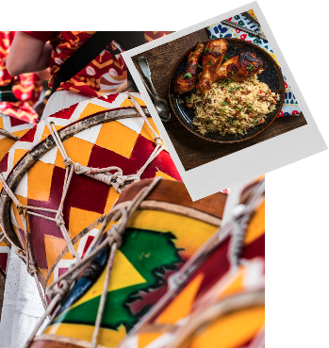
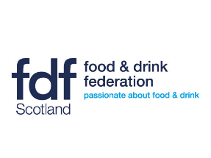
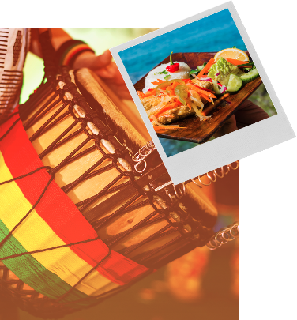
Tilda Street Food Challenge 2022
Sponsored by Tilda Foodservice in partnership with
FDF Scotland and supporting Mary’s Meals

WHAT IS IT?
Tilda, working together with Food and Drink Federation (FDF) Scotland, is delighted to launch the Tilda Street Food Challenge 2022.
Designed to develop employability skills and an understanding of careers in food and drink that supports healthy eating, sustainability and social responsibility, the Tilda Street Food Challenge is open to all S1 – 3 and pupils across Scotland.
We do hope that the challenge can be delivered in schools in 2022 and we have developed the criteria to enable teachers to use this challenge to support curriculum delivery but we understand that the pupils may require additional support from parents / family.
We are challenging pupils to design a new rice-based street food dish that they would like to eat, think about sporting events, festivals
Pupils should:
- Work on their own or in small teams of no more than 3 to take inspiration from today’s food trends influencing the dishes we eat. Think street food, small plates and plant-based cuisine. Pupils may wish to make links with their catering staff, local food producers and farms as part of this process (if that is possible under current restrictions).
- Conduct their own research to investigate what street food young of their age like to eat.
- Use their imagination and creativity to come up with a new street food dish that would really appeal to their target market using any one Tilda’s ambient dry rice’s (* see list below) as the base ingredient.
- Design a marketing campaign to promote their product. We would also ask that as part of this process, pupils investigate where rice comes from, how it is processed, its economic importance to local economies and its health benefits.
- Think about how their dish could be made sustainably and identify ways in which the product can reduce environmental impact and provide details as to how this could be achieved.
- NOTE the judges want to see original ideas and creativity. Any dishes that have been copied from the internet will be discounted from the competition.
- To help understand new food trends pupils may wish to investigate further, some helpful sites can be found EIT Food Trends and Speciality Foods, although other sources may provide more information.
- Entrants should also include nutritional information about their product and potential allergens, see Natashas Law

The Prizes
£30 Amazon vouchers for the winner (s) and a
Panasonic rice cooker for their school and
£15 Amazon vouchers for the runners up, plus other Tilda goodies.

WHAT DO YOU HAVE TO DO
Entries to be submitted on the application form attached email these to skills@fdfscotland.org.uk by 21st May 2022
Please note we request that applications are submitted in the Word document as supplied as we cannot guarantee that we can access other forms of entries
Shortlisted entries will be informed by 6th June 2022.
Judging will take place on an allocated day during week commencing 13th June 2022, dependent upon Scottish Government restrictions. If judges cannot visit in person arrangements will be made to hold a virtual judging process.
IMPORTANT INFORMATION!
The Rice
Tilda ambient dry rice MUST be used in the competition and should make up at least 50% of this dish. The Tilda competition is there to see rice as an integral part of the dish, the hero of the dish, not as a side.
Teams can choose any of the Tilda ambient DRY Rice range, although bonus points will be given for using more than one rice.
*Tilda’s ambient range includes aromatic Tilda Basmati & Wild, naturally fragrant Jasmine Rice, creamy Arborio Rice, nutty Brown Basmati Rice, healthy Brown n White Rice and the champagne of their range, Pure Basmati.
Check out Tilda’s foodservice range at https://www.tilda.com/professionals/professional-range/
WHY ARE WE DOING THIS?
This challenge aims to help students in Scotland in the following ways:
- Raise awareness of the journey that our food makes
- Support educators to deliver the curriculum and encourage interdisciplinary learning
- Understand the process of ensuring healthy, nutritious food gets onto our plate
- Understand the multitude of career opportunities involved in the food industry
- Provide active engagement between pupils and industry
- Encourage educated food choices
- Support health and wellbeing through research and practical application
- Help pupils gain practical skills relevant to future employment opportunities
- Encourage team working and co-operative learning
- Help pupils to understand how the subjects they learn at school are relevant in the real world of work
Note: COVID 19
FDF Scotland and Tilda appreciate that the lockdown restrictions have resulted in a very different educational environment. We have tried to address these exceptional circumstances whilst designing this competition and we do hope that our challenge will help teachers to deliver the curriculum and engage with their pupils as part of the requirement for remote teaching and learning. However, if you have suggestions or queries relating to how you would like to deliver this activity please do not hesitate to contact us skills@fdfscotland.org.uk
HOW CAN THIS ACTIVITY SUPPORT THE CURRICULUM?
The pupils are expected to work in teams to explore and research where food comes from and the stages it goes through to get to the plate or package, including;
• Researching global foods produce and what foods are available locally
Having explored a range of issues which may affect food choice, I can discuss how this could impact on the individual’s health.
HWB 3-34a
• Working with other organisations to find out what is popular and what is possible to produce as a new dish
By using problem-solving strategies and showing creativity in a design challenge, I can plan, develop, make and evaluate food or textile items which meet needs at home or in the world of work.
TCH 3-04c
• Understanding the product development process for new or reformulated products
By using problem-solving strategies and showing creativity in a design challenge, I can plan, develop, make and evaluate food or textile items which meet needs at home or in the world of work.
TCH 3-04c
• Research what pupils would like to eat as part of a healthy balanced diet and the associated benefits
By using problem-solving strategies and showing creativity in a design challenge, I can plan, develop, make and evaluate food or textile items which meet needs at home or in the world of work.
TCH 3-04c
• Develop a marketing plan to promote their new product or products with associated: nutritional breakdown, costings, marketing and promotion plan this may also include appropriate packaging and promotional ideas
By using problem-solving strategies and showing creativity in a design challenge, I can plan, develop, make and evaluate food or textile items which meet needs at home or in the world of work.
TCH 3-04c
This activity also supports delivery of the DYW Career Education Standard (3 -18)
Tilda Street Food Challenge 2022 – COMPANY STATEMENT
Tilda understands the importance of offering nutritious school meals together with educating pupils about different cultures and cuisines from around the world. As part of this activity they want to help pupils in Scotland understand the importance of a healthy balanced diet and understand the journey that their product makes, the people involved in processing this important staple product and the opportunities a career in food can provide.
A socially responsible company Tilda supports several charitable causes including MARYS MEALS, a Scottish based charity. Tilda have also partnered with the world food programme to provide nourishing meals to mothers and the Felix project which donates surplus food to homeless charities.

Terms and Conditions
The competition is run by Food and Drink Federation Scotland and Tilda from 48 Melville St,
Edinburgh EH3 7HF
- All entries should be received no later than 21st May 2022.
- Submission of an entry shall constitute acceptance of all terms and conditions.
- To constitute a complete entry, teams must submit as per above checklist and in the form requested which includes a name for the product, description and ingredients.
- Incomplete entries will not be submitted into the paper judging stage of the competition. All entries will be checked on submission.
- All copyright existing on the entries and any promotional activities undertaken by schools will remain with the individual team. However, by entering the competition entrants agree that FDF Scotland & Partners reserves the right to use any materials submitted including but not limited to photographs for any purpose connected to the competition.
- Entrants will be paper judged by a panel of judges and competition representatives. Entry into the finals will be at the sole discretion of the judging panel.
- Individuals or teams that qualify for the finals will be contacted no later than 6th June 2022.
- The finals will take place week commencing 13th June 2022 and will comprise the judges visiting the school to meet the team (s) and teacher and see the product(s) being made. If face to face judging is not possible provision will be made for a virtual judging process.
- All competition entrants may be required to participate in PR activity during the competition.
- The judging panel’s decision is final.

Tilda Street Food Challenge Entry Form 2022
Remember to double check you have completed all the points on the application form!
Feel free to continue on separate sheets if necessary
Pupil(s) name:

Pupils email: (optional: if you are entering via your school you can leave this blank but if you are entering individually please complete this)

Name and address of School:

Local authority:

Year group of pupils participating:

Name of teacher and contact details: (email and phone):

Name of product:

Please describe the product that you have designed and how it fits with the brief:

Can you tell us who or what inspired your dish?

Please detail the ingredients that would be used in your dish and your method of preparation.

Can you also detail what you have learned in relation to the following.
“We would also ask that as part of this process, pupils investigate where rice comes from, how it is processed, its economic importance to local economies and its health benefits”.

Can you detail how this dish can be made sustainably and identify ways in which the product can reduce environmental impact?

Can you detail how you suggest fundraising ideas to raise additional funds for Mary’s Meals

Please return this form as a Word document to skills@fdfscotland.org.uk no later than 21st May 2022.

